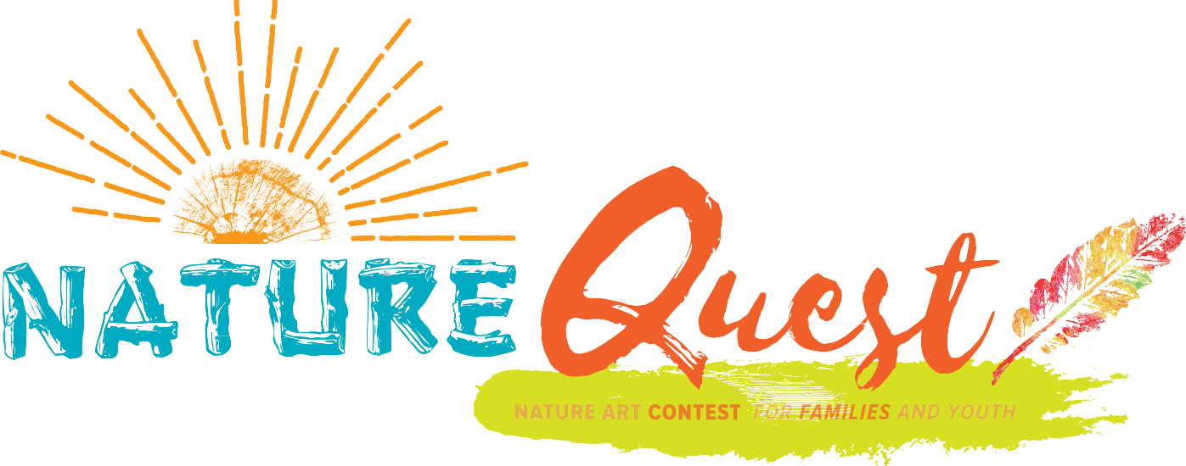

OFFICIAL RULES

1. **General**

These are the official rules and regulations for the Nature Quest Art Contest conducted by the Maryland-National Capital Park and Planning Commission (M-NCPPC), Department of Parks and Recreation, Prince George's County (DPR).

This contest is open to Prince George's County residents who are 18 years old and under. No purchase is necessary. Explore your backyard, a local park, or other outdoor environments. Tell your nature story by drawing, painting, photography, and poetry.

Enter the art contest by uploading your artwork to be displayed in our Nature Quest exhibition!

Entries must be received by no later than 11:59 PM EDT on November 2, 2026=5

Upload entries to our Submittable website <https://m-ncppc.submittable.com/submit>  
You may enter as many categories as you want!   
Entries must be inspired by nature.

1. **Prizes**

Contest prize winners will notified via email/phone by December 1- 5, 2025 and payment will be mailed at least 30 days after the closing of the exhibit on January 21, 2026. Finalists must bring their art to 7833 Walker Drive #200 Greenbelt, MD any day/time between December 8 - 15, 2025 between 9am - 4pm. Artwork pickup will be on Saturday, January 24 at Harmony Hall between 9am-4pm. Be sure to check out the contest categories below to learn more about category-specific prizes that you can win!

1. **Originality and plagiarism policy**

All entries must be original and must not be a copy of any existing work. Whether you intend to or not, claiming someone else's work as your own ("plagiarism") is a serious violation of copyright law. Plagiarism and forgery result in criminal sanctions, fines, and civil damages. You must be very careful to make sure that your creation (s) is original and not the work of other artists. Be creative! Get outdoors, explore nature, and share your experience with us through art.

The best way to be sure your art is an original is to get outside! We strongly encourage all entrants to

go outdoors and experience nature for themselves. Get outside and observe your wild neighbors in their natural environment; make sketches, have a photoshoot in the best possible setting, get wild inspiration for your poetry. This contest is all about having fun and spending creative time outdoors. So, get out there and share your story through art.

1. **Entrant Agreement**

By submitting an entry, the entrant (if 18 years old or older) or the entrant's adult representative (if the entrant is under the age of

18 years old):

* + Certifies that the entry submitted is entirely original.
  + Takes all legal responsibility for breaches of copyright caused by plagiarism.
  + Grants M-NCPPC, Department of Parks and Recreation, Prince George's County a license to reproduce the submitted work, in whole or in part, for any purpose, including research, on the internet, in print publications, and/or in any other medium without compensation of any kind, and to publish the entrant's name, age, and home city/state in conjunction with the artwork.
  + Authorizes persons accessing [www.pgparks.com](http://www.pgparks.com/) or any affiliated websites to view, download, and print the work for personal and classroom educational purposes.
  + If the entrant is under the age of 18 years old, the adult representative assumes all liability for the entrant and indemnifies M-NCPPC Nature Quest in respect of all matters related to the entry.

1. **Judging and Administration**

For the drawing, painting, and photography category. 1st, 2nd, and 3rd place prizes will be chosen from each age group. 1st place is awarded $300, 2nd place is awarded $200, and 3rd place is awarded $100. Poetry will be recognized in a separate category with cash prizes of 1st place awarded $300, 2nd place awarded $200, and 3rd place awarded $100.

*Drawing, Painting, and Photography are all in the same category.

Elementary School: K - Grade 5 Middle School: Grades 6 - 8

High School: Grades 9 - 12

The M-NCPPC, Department of Parks and Recreation, Prince George's County (DPR) administers this contest. DPR reserves the right to disqualify any entrant who violates any of the contest rules, who attempts to influence or receive unfair consideration from the judges, or who tampers with the entry process or the operation of the Nature Quest website. DPR Nature Quest reserves the right to cancel or modify the contest and/or the prizes in the event of unforeseen circumstances beyond the control of DPR that would prevent the normal completion of the contest.

