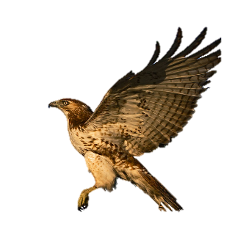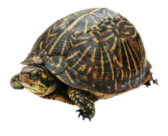

To book a program contact us at 301-218-6702 or email WatkinsNatureCenter@pgparks.com

**Watkins Nature Center**

**Virtual School Programs**

Let us bring our animal ambassadors to your virtual classroom. Programs can accommodate up to 49 students and lasts 45 minutes. Each Program includes an animal show and a question and answer segment with you students.

*$60 Resident / $78 Non-Resident*

**Birds of Prey (2nd grade-adult)**

This one’s for the birds. Let us introduce you to one of the most majestic group of birds, the raptors. Learn how they are grouped as birds of prey and the differences between the different types of these fearsome predators. Meet several raptors and see firsthand the impressive adaptations they have to survive all around the world!

**Invertebrates (2nd – 3rd grades)**

Approximately 95% of all life on Earth are invertebrates. Let our naturalists teach you how something spineless is anything but wimpy! Learn about the different groups of these amazing creatures and how they are so successful at survival. Meet arthropods, arachnids, and insects! These simple creatures are simply cool!

**Reptiles and Amphibians (1st-adult)**

Dive into the fascinating world of herpetology. Explore the differences and similarities between amphibians and reptiles and see how they have adapted to survive relatively unchanged for millions of years. Meet cold-blooded creatures not only from your local area, but from around the world!

**Wild Things (Pre-K-adults)**

See where the wild things REALLY are! Out naturalists will introduce you to a variety of animals, including insects, amphibians, reptiles, mammals, and birds of prey. Discover how we classify animals, their adaptations, and see some that live in your own backyard!

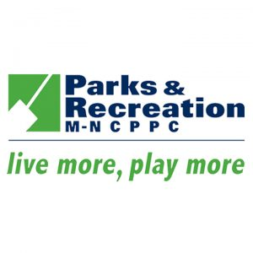

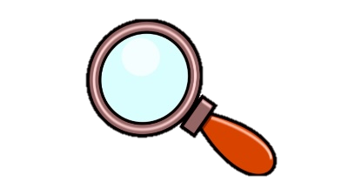

**Watkins Nature Center**

**Hands- On Virtual School Programs**

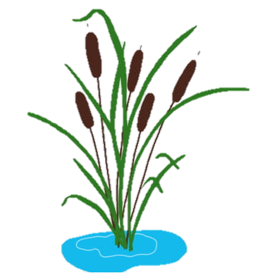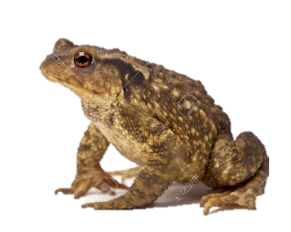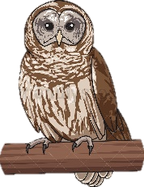

Engage your virtual classroom with hands-on lessons lead by a naturalist. These activities allow your students to bring the experiment home! Teachers will receive kits that can be distributed to the students. Programs can accommodate up to 30 students and last about an hour and a half.

*$80 Resident/ $104 Non-Resident and $5 material fee per student*

**Reptiles and Amphibians (1st grade-3rd grade)**

Dive into the fascinating world of herpetology. Explore the differences and similarities between amphibians and reptiles and see how they have adapted to survive relatively unchanged for millions of years. Meet cold-blooded creatures not only from your local area, but from around the world! Finally build a home for one of our native amphibians!

**Wonderful Wetlands (4th grade- 7th grade)**

Join us as we learn about one of the most important ecosystems on our planet! See how important wetlands are to the health of our local ecosystems and how wetlands act as a natural filter. Build an example of how a wetland works on a small scale and see how salt can affect wetland habitats. Finally, meet some of the wonderful animals that call wetlands home.

**Owl Pellet Lab (3rd grade – 5th grade)**

Enjoy the best of both worlds bringing outdoor observations into your student’s homes! In this hands-on class, students develop science and technology processing skills by learning to use laboratory equipment and recording observations. Students apply the scientific method to draw data driven conclusions from their virtual field studies. Discover the WHOOO and why behind owl pellets! Students are introduced to the biology and life history of owls while learning how to use dissecting instruments. Students dissect owl pellets and use data to determine the habitat use of owls. Finally, meet some live owls from your local area!



To book a program contact us at 301-218-6702 or email WatkinsNatureCenter@pgparks.com